1. **Binary Search using Recursion**

**Output :** 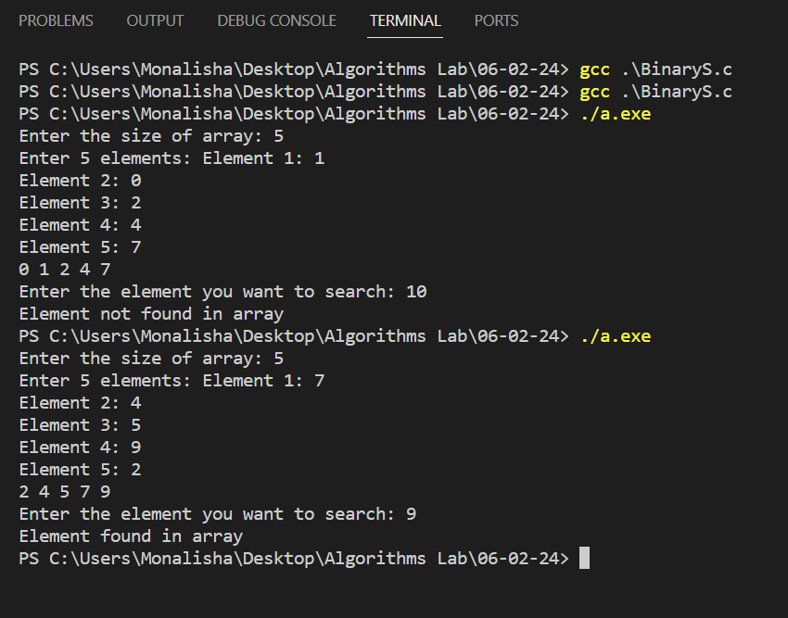

**2. Tower of Hanoi using Recursion**

**#include<stdio.h>**

**int c = 0;**

**void ToHanoi(int n, char s, char a, char d);**

**void main() {**

**int n;**

**printf("Enter the no. of disks: ");**

**scanf("%d", &n);**

**ToHanoi(n, 'S', 'A', 'D');**

**printf("Total number of moves: %d\n", c);**

**}**

**void ToHanoi(int n, char s, char a, char d) {**

**c++;**

**if (n==1) {**

**printf("Move one disk from %c to %c\n", s, d);**

**}**

**else {**

**ToHanoi(n-1, s, d, a);**

**printf("Move one disk from %c to %c\n", s, d);**

**ToHanoi(n-1, a, s, d);**

**}**

**}**

**Output :**

